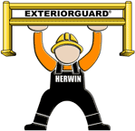
EXTERIORGUARD® OUTDOOR GUARDRAIL WORKSHEET
Contact Name Company Address

Phone Fax Email Zip Code of Destination

For a "Quick Quote" with freight charge
FAX TO: 724-446-0988

DOUBLE RAIL CONFIGURATION

44” high, 42” to top of rail
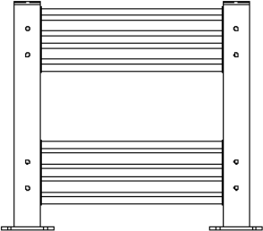

Please sketch your layout below. Beside each rail, note dimension. Layout will be calculated with standard nominal rail lengths of 2, 3, 4, 5, 6, 7 or 8 feet. Nominal rail length dimension is from center of post to center of post. We will respond within one business day with job and freight pricing. If you need layout assistance, please call 1-800-868-5438.

Exteriorguard® by Herwin Safety, Inc.

1-800-868-5438 FAX : 724-446-0988 sales@herwin.biz

©2021 Herwin Safety, Inc. All rights reserved

