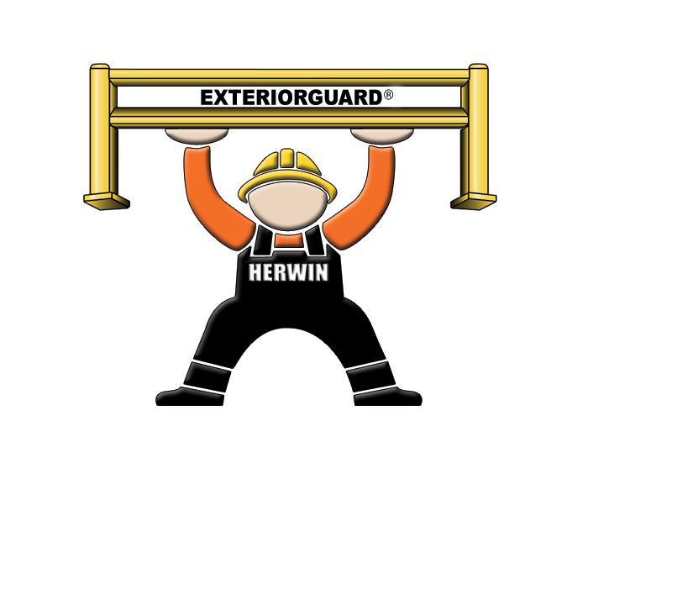Exteriorguard®

Architectural Engineering
Product Specifications

- Exteriorguard® guardrail components shall be designed in accordance with NBC, AISC and CSA standards listed in §13145.3.

- Exteriorguard® post baseplates shall be made of (10” x 10” x ½”) material welded to HSS (5” x 5”) tubular ASTM 500 Grade C metal. Height of posts shall be 44” for double high rail. Posts are pre-punched to accommodate ½” diameter fasteners. Posts shall be designed to accommodate various rail heights.
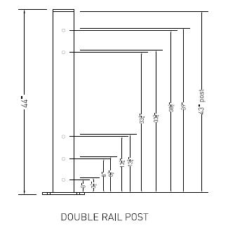

- Exteriorguard® shall have 12” high rails with welded side brackets that are manufactured with ASTM A607 Grade 50 corrugated steel. Installed rail shall be 42” high for double post.
Rail lengths shall be 2 feet to 8 feet nominal.
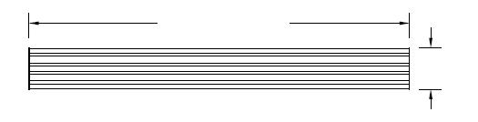

NOMINAL LENGTH

12”

©2010 Herwin, Inc. All rights reserved October 2010

- All components for Exteriorguard® series guardrail shall be powder coated one coat of highly visible safety yellow paint and are intended for outdoor use.

®
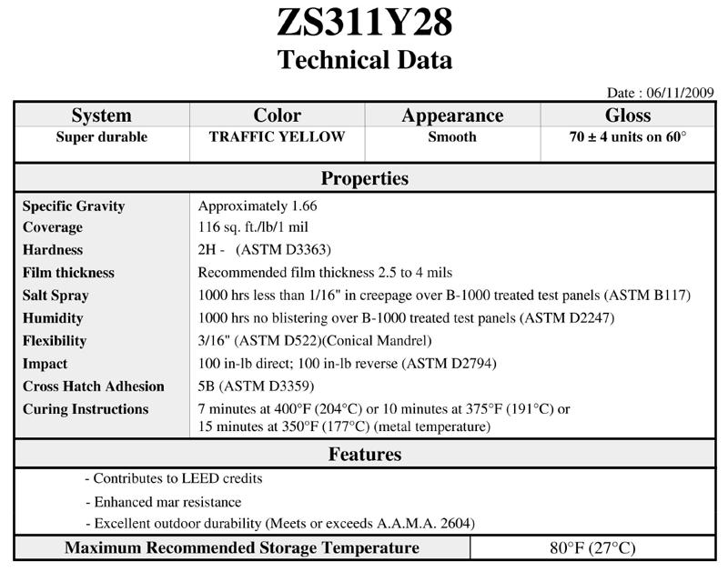

©2010 Herwin, Inc. All rights reserved October 2010

- Exteriorguard® guardrail system shall incorporate a pass through post fastener design.
The (½” x 7”) galvanized carriage bolt shall pass completely through the post and rail bracket.
Bolt shall be secured with washer and nut. Nut shall be tightened 1/3 turn past snug tight condition. Post plates shall be aﬃxed to concrete floor by 4-1/2” x 5/8” galvanized wedge anchors in at least 6” of good concrete.

- The guardrail shall be installed at least 12” away from the surface to be protected. This minimal distance is necessary for deflection of an impacted rail.

- Total system shall be designed to meet or exceed a rating of 10,000 lb. at 4 mph breakthrough when installed in proper concrete depth.

©2010 Herwin, Inc. All rights reserved October 2010

