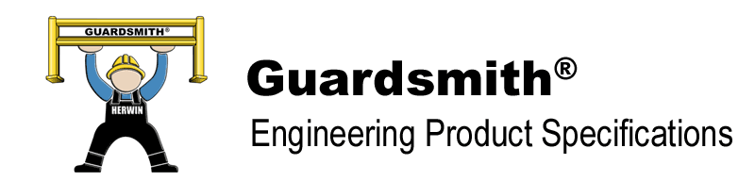
1. Guardsmith® guardrail components shall be designed in accordance with NBC, AISC and CSA
standards listed in §13145.3.

2. Guardsmith® post baseplates shall be made of (10” x 10” x ½”) material welded to HSS (5” x 5”)
tubular ASTM 500 Grade C metal. Height of posts shall be 44” for double high rail and 18” for single
high rail. Posts shall be pre-punched to accommodate ½” diameter fasteners. Posts shall be designed
to accommodate various rail heights.

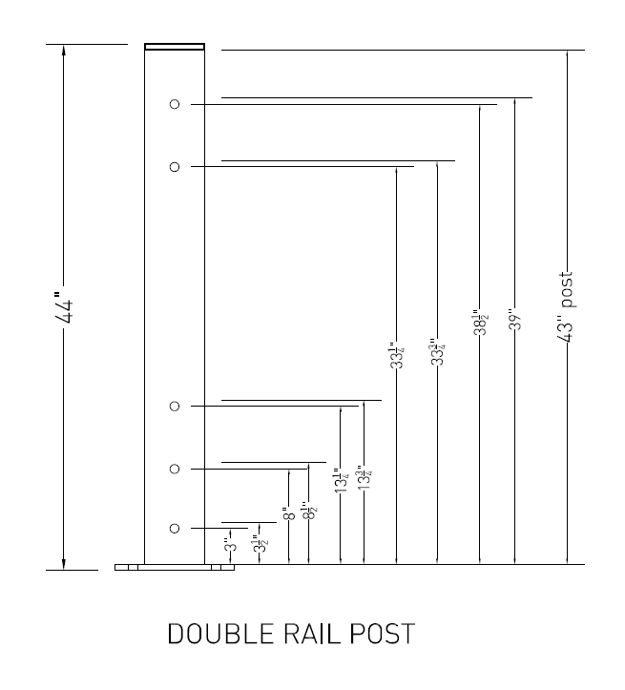

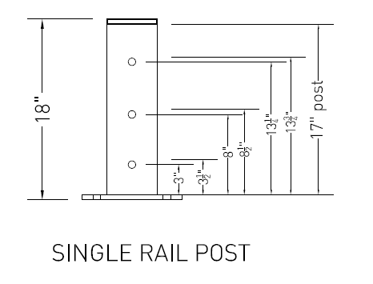

3. Guardsmith® shall have 12” high rails with welded side brackets that are manufactured with
ASTM A607 Grade 50 corrugated steel. Installed rail shall be 42” high for double post and 17” high
for single post. Rail lengths shall be 2 feet to 10 feet nominal.
NOMINAL LENGTH

12”

4. All components for Guardsmith® series guardrail shall be powder coated one coat of highly visible safety yellow paint and are intended for indoor use only.
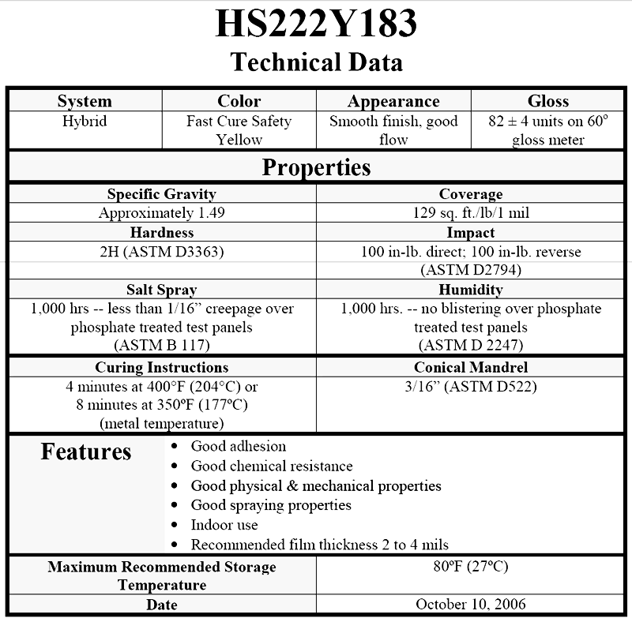


5. Guardsmith® guardrail system shall incorporate a pass through post fastener design.
The (½” x 7”)carriage bolt shall pass completely through the post and rail bracket.
Bolt shall be secured with washer and nut. Nut shall be tightened 1/3 turn past snug
tight condition. Post plates shall be affixed to concrete floor by 4-1/2” x 5/8” wedge
anchors in at least 6” of good concrete.

6. The guardrail shall be installed at least 12” away from the surface to be protected. This minimal
distance is necessary for deflection of an impacted rail.

7. Total system shall be designed to meet or exceed a rating of 10,000 lb. at 4 mph breakthrough
when installed in proper concrete depth. Lift out brackets are not rated.

